

**Department of Computer Engineering**

**Name: Shaikh Adnan Shaukat Ali**

**Roll No: 68**

**Subject: TCS**

**Class/Sem: T.E. / SEM-V**

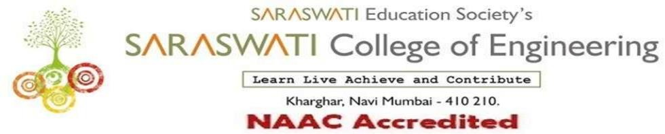

###### Department of Computer Engineering

Subject: TCS Class/Sem:TE/V

**Name of the Laboratory: TCS Year: 2021-2022**

**LIST OF EXPERIMENTS**

|  |  |  |
| --- | --- | --- |
| **Expt. No.** | **Date** | **Name of the Experiment** |
| 1. | 30/07/21 | TUTORIAL-1 |
| 2. | 10/08/21 | TUTORIAL-2 |
| 3. | 31/08/21 | TUTORIAL-3 |
| 4. | 15/09/21 | TUTORIAL-4 |
| 5. | 30/09/21 | TUTORIAL-5 |
| 6. | 18/10/21 | TUTORIAL-6 |

Prof.Dr. Hemlata goswami

Prof. Sujata Bhairnallykar

**Subject In-charge**

**HOD**